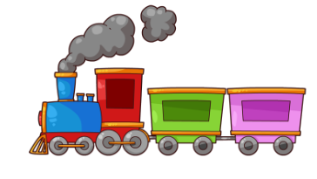
Spring Term 2023 Reception - Miss Sharp and Miss Collett
Our quality texts this term will be based around-
The Train Ride, Journey Home from Grandpas
Communication and Language
• To retell a story using story telling language.
• To learn and use new vocabulary.
• To listen to and talk about stories.
• To listen carefully to rhymes and song, paying attention to how they sound.
• To learn rhyme, poems and songs.
• To follow more complex instructions
• To engage in conversations.
• To take turns in conversations.

Personal, Social and Emotional Development
• To play and work cooperatively.
• To think about the perspectives of others.
• To turn take turns.
• To talk about ways of keeping healthy and safe such as brushing teeth.
• To be a safe pedestrian
• To fasten my coat.
• To put my shoes on.
• To fasten my shoes.
• To put an apron on.
Physical Development
P.E days
Miss Sharp – Monday
Miss Collett - Friday
Please ensure your child comes to school in their PE kit.
• To travel with control.
• To move in different ways.
• To have an awareness of space.
• To move with coordination.
• To combine different movements.
Literacy
• To describe main story settings, main events and principle characters within stories.
• To re-enact stories I have heard.
• To recall stories that I have listened too.
• To sequence a story that I have listened too.
• To read and listen to stories, non-fiction, poems and rhymes
• To recognise Phase 3 phonemes.
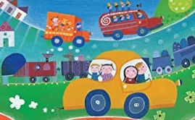
• To blend and segment Phase 3 CVC words.
• To read and write Phase 3 captions.
• To read and write Phase 3 sentences.
• To read and spell some tricky words.
• To write a list.
• To use some finger spaces.
• To attempt to write a sentence
Maths
• To recognise and write 6 7 8, 9 and 10.
• To find ways of making 6 7, 8, 9 and 10
• To recall my number bonds to 6, 7, 8, 9 and 10.
• To represent 6, 7, 8, 9 and 10 in different ways.
• To compare sets of 6, 7, 8, 9 and 10 objects.
• To order sets of objects to 6, 7, 8, 9 and 10.
• To identify one more and one less to 10.
• To find odd and even numbers within 10.
• To use language to describe length and height.
• To order and sequence familiar events.
• To use language now, before, later, after, soon, then and next.

Understanding the Arts and Design
• To recognise that people have different beliefs.
• To recognise that people celebrate special times in different ways.
• To recognise similarities and differences between life in this country and life in other countries.
• To explain natural processes such as: ice melting.
• To recognise and name some animals.
• To talk about members of my immediate family and community.
Expressive Arts and Design

•To Use different mediums such as, paint, pastel, wax crayons etc…
• To talk about my work and how I created it.
• To adapt and improve my work.
• To listen and move to music.
• To sing a range of well-known nursery rhymes and songs.
• To talk about music and how it makes me feel.

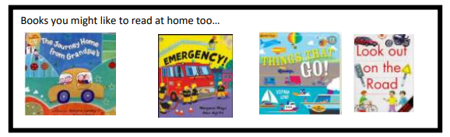

Phonics
This term your child will be learning some Phase 3 phonemes
ai in rain
ee in see
igh in light and night
oa in boat or coat
oo the short sound in book and look
oo the long sound in zoo and moon
or in fork
ur in fur and burn
ow in cow
oi in boil
ear in hear and beard
air in hair
er in tower

Reading Books
Reading at home is so important to help the children build on those skills they have been taught at school and what better way to learn when they are finding it so pleasurable. Please sign your child’s reading record when you have listened to them read at home.

You child has two books:

- A picture book This book just has pictures and gives your child the opportunity to develop their language skills, by talking about the pictures and making up their own story.
- A Sharing book This book has some words but you child might not be able to read the words at the moment. It is for you to share with your child.

As your child’s phonics skills develop we will move your child onto these two books:

A reading practice book –Collins Big Cat
- This book has been carefully chosen and matched to your child’s phonetic ability and will be at the correct phonic stage for your child. They should be able to read this fluently and independently. We encourage children to read this book three times.

- A sharing book. Your child may not be able to read this book on their own as it is not fully decodable and may not match their exact phonics level. This book is for you both to read and enjoy together.

