BUSHFIELD ROAD INFANT SCHOOL
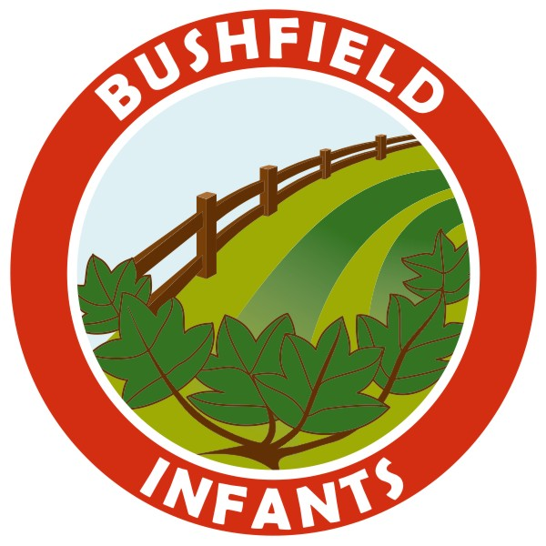


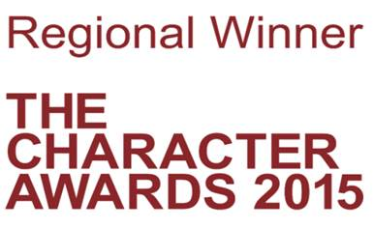
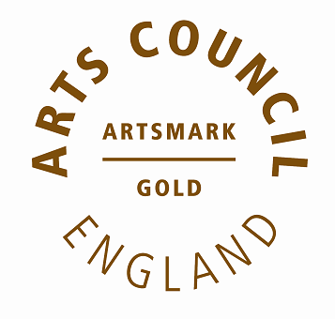

Dear Parents/Carers,
Following the Prime Minister’s announcements on Sunday and the subsequent guidance from the DFE, I am sure you will have lots of questions about the government’s proposed return to school for some year groups on June 1st.
At this moment there will be no change to the school’s current arrangements to provide child care for the children of critical key workers; that is those children who have already been attending school to enable their parents to work in frontline services.
Like yourselves we have many questions regarding the proposed return to school and over the coming days we hope to receive additional advice and support from both the Government and our local authority, which will help us to plan ahead.
It is important that you are aware that the original guidance regarding Year 1 pupils returning on June 1st was aimed only at Primary schools and that the guidance for Infant schools is that the Nursery and Reception children would be the proposed groups.
I would like to offer you reassurance that when considering the return to school proposals, we will follow procedures and advice in accordance with the Government guidance, specifically relating to the health and safety of your children. These proposals present a significant challenge for us as an Infant School, specifically around social distancing and therefore at this time we are unable to provide further details.
We will continue to take advice and ask for your patience and understanding in these extremely difficult circumstances. As soon as we have a clear plan which will enable the safest possible return to school for our Nursery and Reception children, we will let you know. For those families who make the decision to keep their children at home, we will continue to provide home learning resources. In the coming week, the school will make contact with all Reception and Nursery parents to gather valuable information about the numbers of families who would be sending their child to school in June, assuming the school is able to re-open.
Teachers will continue to provide resources for all those children in Year 1 and Year 2 who will be remaining at home and we thank you all for your hard work in supporting your children with their home learning. Please remember there are lots of resources on the school website. www.bushfieldinfants.co.uk

I am sure you will join me in thanking all school staff and key workers who continue to show commitment and dedication during this challenging time.

Thank you
Mrs T Bass

