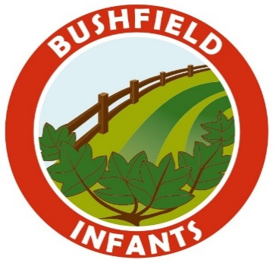
BUSHFIELD ROAD INFANT SCHOOL
Dear Parents/Carers
You may have seen in the local news that cases of COVID 19 are on the rise in our area and that our hospitals are quickly becoming overwhelmed with new admissions. It is therefore vital that during this second lockdown period that we all follow the new national restrictions to control the spread of coronavirus (COVID-19).
Our school will continue to remain open, as we have since the start of the pandemic, and we will continue to remain open this autumn term for the duration of the national restrictions.
Being at school is vital for children’s education and for their wellbeing. Time spent out of school is detrimental for children’s cognitive and academic development, particularly for disadvantaged children. This impact can affect both current levels of education, and children’s future ability to learn. It continues to be our aim that all our pupils remain in school full-time.
The risk to children themselves of becoming severely ill from coronavirus (COVID-19) is very low and there are negative health impacts of being out of school. For the vast majority of children, the benefits of being back in the classroom far outweigh the low risk from coronavirus (COVID-19) and we should all take action to reduce risks still further.
If your child is absent from school for any reason, especially with any symptoms of coronavirus (COVID-19), it is important that you telephone school on the first day of absence. We will ask for the reason for absence and advise accordingly should any symptoms relate to coronavirus (COVID-19). We have a duty to advise the local authority and the Department for Education if a child is absent due to coronavirus (COVID-19), including self-isolation due to suspected or confirmed cases within the household.
Failure to contact school when your child is absent for any reason, may result in an absence being recorded as unauthorised and categorised as truancy. Please be aware that we will still be following our absence procedures and you may receive telephone calls and letters from school should your child be persistently absent.
Our staff are working extremely hard to ensure that our school continues to stay open and safe but we also need your help. We are asking parents again to help us and everyone in our school community by ensuring that you continue to adhere to our guidance:-

- Unless you are exempt, WEAR A FACE COVERING at all times on the school premises.
- DO NOT arrive at school any earlier than your child’s drop off and collection time.
- Only ONE ADULT should accompany their children within the school grounds.
- DO NOT allow your children to run around and play with their friends within the school grounds and DO NOT allow them to climb on the outdoor furniture and equipment. Children MUST remain with, and be closely supervised by an adult.
- Keep your distance from the classroom doors when dropping off or collecting your children to keep our staff safe. Please DO NOT attempt to speak to the staff at the doors. If you have a message, please telephone the school office. Staff will ask parents to move along in order to limit adult contact.
- Once you have dropped off or collected your child, LEAVE THE SCHOOL GROUNDS PROMPTLY.
- MAINTAIN SOCIAL DISTANCE from other families to keep yourselves, your children and other people safe.
- Please park responsibly during this period. We have had a number of complaints from local residents who have had difficulty accessing their homes safely.
THANK YOU
Mrs K Turnbull
Deputy Head Teacher

