Bushfield Road Infant School

Marking & Feedback Policy

Date of Policy: September 2023
Date of policy approval by Governors: November 2023
Date of next policy review: September 2025

Marking & Feedback Policy
‘Teachers use assessment to check pupils’ understanding in order to inform teaching, and to help pupils embed and use knowledge fluently and develop their understanding, and not simply memorise disconnected facts.’ OfSTED 2019
- Ofsted does not specify the frequency, type or volume of marking and feedback in pupils’ books or folders. Ofsted recognises that the amount of work in books and folders will depend on the subject being studied and the age and ability of the pupils.
- When used effectively, assessment helps pupils to embed knowledge and use it fluently, and assists teachers in producing clear next steps for pupils. However, assessment is too often carried out in a way that creates unnecessary burdens for staff and pupils. It is therefore important that leaders and teachers understand its limitations and avoid misuse and overuse.
- Inspectors will therefore evaluate how assessment is used in the school to support the teaching of the curriculum, but not substantially increase teachers’ workloads by necessitating too much one-to-one teaching or overly demanding programmes that are almost impossible to deliver without lowering expectations of some pupils.
Principles & Purpose
Feedback is an integral part of the assessment process as it is integral to promoting children’s learning; feedback should make learners think!
The Teachers’ Standards state that teachers should:-
‘give pupils regular feedback, both orally and through accurate marking, and encourage pupils to respond to the feedback.’
However, the impact on teacher workload must be taken into account when reviewing, developing and following marking practice.
In our school, marking and feedback will be given verbally and include written comments for children to respond to. Consistently high quality marking and constructive feedback from teachers will ensure that all pupils make rapid gains.

Marking and feedback will:-
- be consistent, specific, accurate and clear
- give effective and constructive feedback (both written or verbal)
- promote the quality of learning and show how work can be improved
- make children feel proud of their achievements and indicate next steps/ways forward
- provide teachers with opportunities for assessment of understanding, possibly leading to adaptation of future lessons through planning or grouping
- be directly related to the learning objective of the lesson
- encourage and support further effort and good working habits
- include peer and self-assessment to enhance learning
- help parents to understand strengths and weaknesses in a child’s work
Opportunities for feedback during the lesson should be frequent and allow children to respond as soon as possible.
Marking and feedback should:
• be manageable for teachers and accessible for children;
• relate to the learning purpose / success criteria and comment on previous attainment within the context of the learning purpose / success criteria;
- improve adult intervention in the classroom;
• give recognition and praise for achievement and clear strategies for improvement;
• allow specific time for children to read, reflect on and respond to marking;
• respond to individual learning needs;
• inform future planning and target setting;
• use consistent codes across the school;
• ultimately be seen by children as a positive approach to improving their learning.
Marking
A common and consistent method of marking will be used by all staff:-
- Teachers comments will be linked to the learning objective/success criteria of the lesson and should be accessible to pupils according to age and ability
- Teacher comments will be written in black pen
- Teachers comments will be written using the agreed handwriting style to provide a good model for the children and set high expectations
- A marking code has been created, which is designed to reduce teacher time and the need for lengthy comments.
- We have adopted a colour-coding system to support the children with their editing. PINK is THINK and GREEN is GREAT. This allows the teacher (or peers) to highlight areas of work. Marking in pink highlighter/pen indicates a development point and requires the children to think about what they have done. Marking in green indicates good work.
- ‘Target met’ stamps will be used to identify whether the learning objective has been met in books
The school makes use of three forms of feedback:
- Verbal Feedback
The adult will initially talk to the child about how they have met the learning purpose or success criteria and then question the child about a specific part of the work. This may be to correct a child’s understanding or to extend the child’s learning

- Written Feedback: Summative Feedback /Marking
This usually consists of ticks and dots and is associated with closed tasks or exercises where the answer is either right or wrong.

- Written Feedback: Formative Feedback /Marking
Not all pieces of work can be marked in depth. Teachers decide whether work will simply be acknowledged or given detailed attention. Acknowledgement should always relate to the learning purpose and success criteria. More detailed comments should refer to any improvements that need to be made.

Detailed marking requires teachers to:
• Read the entire piece of work.
• Provide a focused comment to help the child “close the gap” between what they have achieved and what they could potentially achieve. What does this child need to do in order to improve their next piece of work?

Think pink highlight / Responding to Feedback
This should be completed in ‘Response Time’ at the start of the next lesson. The teacher can write a modelled sentence to be copied for a LA pupil. The teacher does not need to write a modelled sentence to be copied for AA or HA pupil, they are expected to correct their own sentence by rewriting it until it is correct.

Useful ‘closing the gap’ comments are:

• A reminder prompt (eg. Use time connectives, What else could you say about …?)
• A scaffolded prompt (eg. What was the monster doing?, The monster was so angry that he…)

• Incorrect answers should be dotted and not crossed. They should be highlighted in pink to show where children are correcting a wrong answer or consolidating the learning from the lesson. It might be a question they got wrong with pictures drawn to help them solve it. When appropriate, in order for the marking to be formative, the feedback given must be used and acted on by the children. Therefore, time should be planned in a future lesson for children to respond to feedback.
Teachers need to model the marking process to the children at the beginning of each year, so that the children are clear what the different marking codes mean and what is expected of them when they respond.
- A finished piece of work will be ruled off by the teacher using pen or pencil so that children can begin the next piece of work underneath
- In KS1, teachers will ensure that pupils write the date and title for each piece of work
- Subject codes will be used next to the title to identify foundation subjects eg. S for Science
- In KS1, pupils will be encouraged to edit their work using a purple polish pen.
- Teachers will ensure that children set high expectations for themselves and their work. High standards in presentation and handwriting will be encouraged.
Regular work scrutiny by the SLT will ensure that high standards in marking are maintained and that marking is consistent and effective across the school

Foundation Stage Marking Policy
Nursery
In Nursery the adult will annotate children’s drawings and mark making in black ink and using the following key. Adults will include any words or phrases the children said whilst mark making. When a child is ready for letter formation, the adult will scribe in a pink highlighter for a child to write over.
Pencil Grip
PG – Palmar Grip
DPG – Digital Pronate Grip
4FG – Four Finger grip
STG – Static Tripod Grip
TG – Tripod Grip
Handedness
RH – Right Hand
LH – Left Hand
I - Independent
PS – partially supported
FS – full adult support
HOH – Hand over hand
C – copied from adult scribe
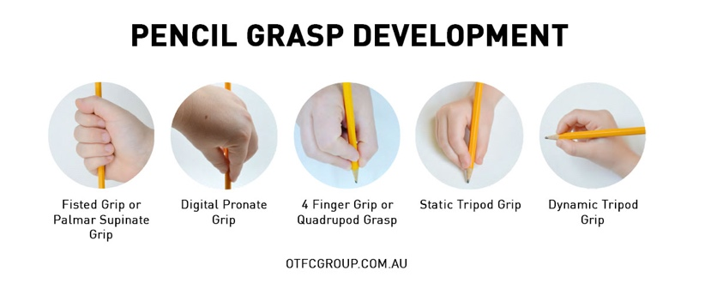
Reception
In Reception, the adult will annotate children’s work, as appropriate, in black ink and using the following key. Adults will include any words or phrases the children said whilst completing their task.
Think Pink
- When practising letter/number formation, the adult will scribe in a pink highlighter for a child to write over.
- The teacher will write the correct GPC/spelling of tricky words, etc, for children to copy.
- ‘Fix it’ will be used in Maths and highlighted in pink.
Green is Great - Marking in green indicates good work.
‘Target met’ stamps will be used to identify whether the learning objective has been met in books.
Pencil Grip – To be recorded on half-termly writing assessments.
PG – Palmar Grip
DPG – Digital Pronate Grip
4FG – Four Finger grip
STG – Static Tripod Grip
TG – Tripod Grip

Handedness – To be recorded on half-termly writing assessments.
(Only for those children who are undecided about which hand to use.)
RH – Right Hand
LH – Left Hand

Marking Codes and Annotations
Target met stamp | Learning objective achieved
I | Independent
S | Support
WT | Working towards target
Ch | Challenge
HOH | Hand Over Hand
C | Copied from adult scribe
/ | Finger Spaces
___ | On the line
Sp | Spelling

Black pen | Teacher Comments
Green | Great
Pink | Think

KS1 Marking Codes and Annotations
Target met Stamp | Learning objective achieved
/ | Finger spaces
__ | On the line
C | Capital letter
T | Tense
Sp | Spelling
S | Supported
WT | Working towards target
Challenge | Challenge

Black pen | Teacher comments
Green | Great
Pink | Think
Purple | Polish (Editing)

MODERATION OF POLICY
The Head Teacher is responsible for monitoring the implementation of this policy. The SLT and Governors use discussions with staff, progress meetings, lesson observations and work scrutiny to monitor the implementation of this policy.

- Written: September 2023

- To be reviewed: September 2025

